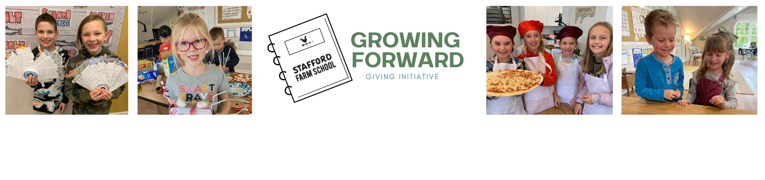Dear Friends & Family,

Ralph Waldo Emerson once said, “Do not go where the path may lead, go instead where there is no path and leave a trail.” That, in so many ways, defines Stafford Farm School. We are doing something different and our model of education is transforming students, influencing families and changing our community.

For three years we have witnessed the way that our hybrid model of education strengthens families, elevates the parents' influence, provides a slower pace of life and elongates childhood. We cherish these things deeply and desire to share them with as many families and children as possible.

With that said, Stafford Farm School is making room for 70 new students to join our community for the 2023/2024 school year. That will require us to create 4 more classroom spaces which we are so excited about. Our school was built on the love, support and generosity of others and our future will be made in much of the same way.

We are inviting you to be a part of our Growing Forward initiative! We have established a priority list of items that need to be purchased in order to create space for our new students. We would like you to thoughtfully consider making a contribution. No gift is too small! We believe in the power of community and we have faith that together, we can grow forward and truly make an impact!

Here is the exciting part: we have a generous donor that has agreed to match every contribution made between March 1st - May 31st up to $15,000!!! That means that every donation made will have DOUBLE the impact!

All donations are tax-deductible and will undoubtedly give these kids a beautiful space to “grow forward!” Thank you for considering how you can champion our students!

Many Blessings,
Stafford Farm School

Ways to Give:
- Visit our giving page to select items and donate online: staffordfarmschool.org/growingforward
- Use the list included to select your items and mail it back with a check:
Stafford Farm School
6495 SW Wilhelm Rd Tualatin, OR 97062
